1. **Introduction to the project:**

**Project Request:**

This project is allowing customers to browse, select, and purchase footwear online. It provides a convenient and seamless shopping experience for customers, with a wide selection of shoes, competitive prices, and valuable insights for business owners. Customers should be able to easily search for products by brand, style, size, colour, and other criteria.

**Purpose:**

The main purpose of an online shoes shop is to provide customers with a convenient and affordable way to purchase shoes. Or the main purpose of an online shoe shop is to sell shoes to customers over the internet

Online shoe shops offer a number of advantages:

Convenience: Customers can shop for shoes online at any time of day or night, from anywhere in the world. They don't have to travel to a store or wait in line.

Selection: Online shoe shops typically have a wider selection of shoes than brick-and-mortar stores. This is because they don't have the same space constraints.

Prices: Online shoe shops often have lower prices than brick-and-mortar stores. This is because they have lower overhead costs.

**Objectives of the proposed system:**

To increase sales by a certain percentage.

To expand into new markets.

To launch new product lines.

To improve customer satisfaction.

To reduce operating costs.

Main Features of the proposed system:

Product catalogue: The system should have a comprehensive product catalogue with a wide selection of shoes from different brands and categories. Each product should have detailed information, such as images, sizing charts, and customer reviews.

Search and filtering: The system should allow customers to easily find the right shoes for their needs by providing advanced search and filtering capabilities. Customers should be able to search by brand, category, size, colour, price, and other criteria.

Shopping cart and checkout: The system should have a user-friendly shopping cart and checkout process. Customers should be able to add items to their cart, review their order, and enter their shipping and payment information quickly and easily.

Secure payment processing: The system should use a secure payment processing system to protect customers' financial information.

Shipping and delivery: The system should offer efficient and reliable shipping and delivery options. Customers should be able to choose the shipping method that best meets their needs and budget.

Customer service: The system should provide excellent customer service, including features such as live chat, email support, and a phone number that customers can call with questions or problems

1. **Scope of Work:**

Planning: This phase involves defining the requirements of the system, such as the features, functionality, and target audience. It also involves developing a project plan and timeline.

Design: This phase involves designing the architecture of the system, including the database, user interface, and backend logic.

Development: This phase involves coding the system according to the design specifications.

Testing: This phase involves testing the system to ensure that it meets all of the requirements and is free of defects.

Deployment: This phase involves making the system available to users.

Maintenance and support: This phase involves providing ongoing support and maintenance for the system.

This is the powerful automated system which will help the management to get various kinds of information. The system is very fast and user friendly. The scope of the proposed system is bright. This system will prove the best solution for the problems of current system. We have used SQL SERVER as our backend tool and Visual Basic as front-end tool. Visual Basic is very powerful for programming purpose. Visual basic is easy to use and it provides better GUI than others. The performance of the software also increases up to its maximum speed. The operating system is windows 10. The existing system was manual and time consuming to enter the data. It was very difficult to maintain all the records manually and refer the records when necessary. So, we decided to make a computerized system. Our system has tried to manage mostly all the information and forms.

1. **An Existing System:**

The existing system is manual. The existing system maintains all the records like particular’s information, customer information and reports. The manual system is very slow and time consuming. The existing system contains large number of errors due to manual system. So, we decided to make a computerized system, which is less time consuming and error prone.

The current system is developed in Visual Basic and SQL SERVER. Visual Basic is used as a front-end and SQL Server as Back-end. As Visual Basic provides better GUI and easy, fast and logical coding. We have used Visual Basic as front-end. The Current System is powerful and it consists of all types of information required. We have tried to manage almost all the information computerized. So this system is more powerful than the existing system. The current system is user-friendly. So, it is easy to operate. Therefore, the Current System is capable of handling all needs of the present scenario. It has more advantages over existing system.

1. **Problem Identification:**

The problems faced by existing system are described as below:

Difficulty in maintenance of records.

Competition

Time Consuming

Difficult return Process

Long Shipping time

Shipping Costs

**Difficulty in maintenance of records**

Online shoes shops typically process a large volume of data, including product information, customer data, and order data. This can make it difficult to keep track of all of the data and ensure that it is accurate and up-to-date. It is also difficult to maintain old files and register which have data of past years which has kept for future references.

**Competition**

The online shoes market is highly competitive, with many different retailers vying for customers' attention. This makes it difficult for retailers to stand out from the crowd and attract new customers. Online shoes shops need to invest in marketing and advertising to reach their target customers and generate brand awareness.

**Time Consuming**

**.** if the shop sells shoes from different brands and suppliers. This includes tasks such as adding new products, updating product information, and tracking inventory levels.Processing orders can also be time-consuming, especially if the shop has a high volume of orders. This includes tasks such as verifying customer information, packing orders, and shipping orders.

Maintaining an online shoes shop's website can also be time-consuming. This includes tasks such as updating the website's content, fixing bugs, and ensuring that the website is secure.

**No Safety of Data**

online shoes shops collect a large amount of customer data, including personal and financial information. This data can be valuable to hackers, who can use it to commit identity theft, fraud, and other crimes.

If the data goes in the hand of wrong person, then he/she may take the advantage of the data.

**Difficult Return Process**

The return process for online shoes shops can be complex and time-consuming. This may involve contacting customer service, printing out a return label, and packaging and shipping the shoes back to the store. Shipping shoes back to an online store can be expensive, especially if the customer is located in a different country.

**Long Shipping Times**

Shipping times can vary depending on the retailer and the customer's location. However, some online shoes shops have very long shipping times, which can be frustrating for customers.

Standard shipping is typically slower than expedited shipping. The shipping method that the customer chooses can also affect shipping times.

**Shipping Costs**

Shipping costs are a major concern for online shoe shops. Shoes can be relatively large and heavy, which can increase the cost of shipping. And also fuel and standard shipping methods are increasing the cost of shipping.

1. **Need of Propose System**

Main resource for the Computerization of online shoes shop: Provide services in better, understandable and Cost-effective manner to the customers and dealers.

To increased sales.

To improve customer satisfaction.

More efficient marketing.

To improve the efficiency to service.

Customer’s records were stored.

1. **Feasibility Study**

The project's viability is stated in the feasibility report. Technical, economic, and operational feasibility are all considered in this study. Technical feasibility measures a system's potential for future system development based on its technical aspects. The essential issue to think about in this case is whether the available tools, programs, and workers are sufficient for the project. The question of whether the new system will be more cost-effective than the current one is known as economic feasibility. Operational viability assesses the system based on user approval.

**Operational Feasibility:**

A multitude of methods and technologies can be used to operate an online shoes system effectively and efficiently. For instance, inventory levels and orders can be monitored using a web-based inventory management system. To manage client interactions and keep track of sales, a customer relationship management (CRM) system can be employed. Additionally, orders can be shipped to customers via a shipping and fulfilment program.

**Technical Feasibility:**

Technically speaking, an online shoe system could be created. The system can be developed using a variety of current e-commerce platforms. Additionally, a variety of currently available software programs can be utilized to handle inventory, orders, and shipping.

**Economic Feasibility:**

Economically speaking, the creation and introduction of an online shoe system is possible. The system's development, marketing, and promotion expenses will all be included in the launch costs. The cost of goods sold, marketing charges, and administrative costs will all be included in the operational costs. The volume of sales and the average selling price of shoes will affect the projected revenue.

1. **System Features**

The current system handles all stock activities and procedures manually.

Contact customer support for assistance with your order, product questions, or other issues.

**The bills are prepared by analysing prices from the individual's information files, a time-consuming process.**

View detailed information about each shoe, including images, descriptions, and reviews.

Customers can pay for their purchases using a variety of payment methods, such as Gpay or COD (Cash on Delivery) Methods.

1. **Hardware requirement of the system**

The phase of the software development process deals with a brief study of different hardware used in the computerized system. There is a list of hardware materials used during the marking and also during the use of the proposed system. As the new system to be made into a computerized function system, requirement of a computer is generally the basic configuration of a typical office computer. A list of the hardware requirement used in the system given bellow.

|  |  |  |
| --- | --- | --- |
| Components | Minimum | Recommended |
| Processor | 2.5 giga hertz (GHZ) | Dual processor that are each 3 GHZ or faster |
| RAM | 1GB | 2GB |
| Disc | NTFS file system – formatted partition with a minimum of 3GB of space | NTFT file system formatted partition with 3GB of free space plus adequate free space foe your web sites. |
| Driver | DVD Drive | DVD drive or the source copied to a local or network accessible drive. |
| Display | 1440 * 900 | 1440 * 900 or higher |

**Software Specifications:**

Operating System : Windows 2000 or letter

Front End: Microsoft Visual Studio 2010 (ASP.NET with C#)

Back End: SQL Servers 2008

**An Overview of The Visual Studio .net Framework:**

Unless you have been living under a rock for the past year, you must have heard of .net

(“dot net”) by now. What is .net? Is it a new operating environment? Is it a new language? Is it a new way of developing distributed applications? The answer is “Yes”.

.net is all of these things and more.

The .net would was created by Microsoft to allow users to have access to their information, files, or programs anywhere, anytime and on any platform or device.

When Microsoft introduced the first window operating system, it took application development and system design to a new level: multi-tasking. With each new version of Windows, multi-tasking has been driven more towards distributed processing and .net is the next step.

Visual Studio .net has an entirely new, object-oriented framework. In this paper I will introduce you to some of features in visual studio.net, however, I will focus mostly on Visual Basic.net and draw some comparisons to its predecessor VB 6. The reader of this paper will not be able to start developing code in Visual Basic.net after reading, but should have a high-level view of the changes in Visual Basic.net and how they differ from previous versions.

**.NET Framework Components**

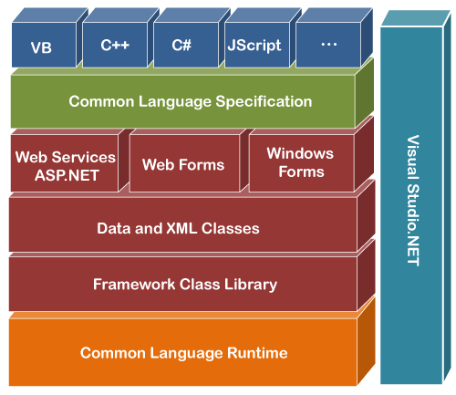

As shown in above figure, Visual Basic sits at the top of the framework (along with the other language in Visual Studio.net). Below that is the Common Language Specification (CLS). This specification is as set of rules that govern the minimum language features that must be supported to ensure that a language will interoperate with other CLS compliant components and tools. As long as a language conforms to the CLS, it is guaranteed to work with the CLR. In this way, when third-party compliers target the .net framework, as long as they conform to the CLS, the code is guaranteed to work.

You might also notice that VB is now and “equal” or peer of C++, C# and any other language that is .net compliant. Visual Basic.net shares the same variable types, arrays, user-defined types, classes, graphical forms, visual controls and interfaces as these other languages.

**Web Services**

Web services provide a Web-enabled user interface with tools that include various HTML controls and Web controls. Forms creating using Web Services are the same as forms created for a Window Application. The code behind a Web form is the same as the code behind a Window Form. The markup language that is used by Web forms is still there, but the Web Form applications generate it for you.

**User Interface**

At the same level as Web Services is the User Interface. The User Interface is where Windows forms live. It also provides code for drawing to the screen, printing, rendering text and displaying images.

**Data and XML**

Both Web Services and the User Interface sit on the top of the Data and XML block. As you will learn later in this paper, XML (or extensible markup language) plays just as important of a role as data. XML is used to provide a text view of data that can be shared between services on the same PC or passed through a firewall to a web server across the country using SOAP (more on SOAP a little later).

**Base Class Library**

The base class library (BCL) is underneath the data and XML block. This area is the origin for the base class of all .net programs. Everything in Visual Basic.net is an object, and all objects originate from a class named *System.* The BCL also provides collections, localization, text objects, interoperability with non-net code and ActiveX controls and a variety of other services.

**SQL SERVER**

**Introduction**

The ability to transform corporate data into meaningful and actionable information is the single most important source of competitive advantage in today’s business world. Harnessing the data explosion to better understand the past and get direction for the future has turned out to be one of the most challenging ventures for enterprise Information Technology department in global organizations. There are three board categories of issues associated with data integration:

Technology challenges

Organizational issues

Economic challenges

In this paper, we will explore these challenges in detail and discuss how to address them with Microsoft® SQL ServerTM2008 Integration Services (SSIS). First you should view them in the context of a real-world scenario.

**A Real-World Scenario**

A major global transportation company uses its data warehouses to both analyse the performance of its operations and to predict variances in its scheduled deliveries.

**Data Sources**

The major sources of data in this company include order data from its DB2-based order entry system, customer data from its SQL Server-based customer relationship management (CRM) system, and vendor data from its Oracle-based ERP system. In addition to data from these major systems, you incorporate data from spreadsheets that track “extraordinary” events into the data warehouses, which shipping supervisors have entered by hand. Currently, you incorporate external data such as weather information, traffic status and vendor details (for subcontracted deliveries) on a delayed basis from text files from various sources.

**Data Consumption**

Not only are the sources for these data diverse, but the consumers are also diverse both in their requirement and their geographic locations. This diversity has led to a proliferation of local systems. One of the major efforts for the Information Technology department is too establish a “Single version of the truth”, at least for its customer data.

**Data Integration Requirement**

In view of this diversity of data, business needs and user requirement, the Information Technology department has specified the following set of data integration requirement:

They must provide reliable and consistent historical and current data integrated from a variety of internet and external sources.

To reduce lags in data acquisition, data from providers and vendors must be available via Web services or some other direct mechanism such as FTP.

They need to cleanse and remove duplicate data and otherwise enforce data quality.

Increasing global regularity demands require that the company maintain clear audit traits. It is not enough to maintain reliable data, the data needs to be tracked and certified.

SQL Server 2008 capabilities deliver on the four key areas of the data platform visions.

**Mission-Critical Platform:** SQL Server 2008 enables IT groups to be more productive by providing a more secure, scalable, and manageable platform. It includes a new policy-based management framework that shifts from managing by scripts to managing by rules. SQL Server 2008 also protects valuable information in existing applications and disconnected devices. In addition, SQL Server 2008 delivers predictable query performance with an optimized platform.

**Dynamic Development:** - SQL Server 2008 along with the .NET Framework enables developers to build the next generation of application. Developers are more productive because they work with business entities instead of tables and columns. They can build application that enables users to take their data with them and synchronize their data with back-end servers.

**Beyond Relational Data:** - SQL Server 2008 enables developers to consume any type of data, from XML to documents, and build applications that incorporate location awareness.

**Pervasive Business Insight –** SQL Server 2008 provides a scalable infrastructure that can manage reports and analysis of any size or complexity while at the same time empowering users because of its close integration with the Microsoft Office System. This enables IT to drive business intelligent throughout the organization. SQL Server 2008 makes great strides in data warehousing, enabling users to consolidate data marts in an enterprise data warehouse.

1. **DATA FLOW DIAGRAM (DFD): -**

Data Flow Diagram is a graphical presentation for defining inputs, processes and outputs.

Data flow diagram is a graphical tool used to describe and analyses the movement of data through a system-manual or automated-including the Processes stores the data, and delays in the system.

The transformations of the data from input to output through the Processes may be described logically and independently of the physical components Associated with the system. They are termed logical data flow diagrams.

In contrast, physical data flow diagrams show the actual implementation and the movement of data between people departments and workstations.

The simple notations are flow understood by users and business persons who are part of the process being studied. Therefore, analysts can work with users and actually involve them in the study of data flow diagram.

The data flow diagram covers all the processes and data storage area, which takes place during any transaction in the system. The data flow diagrams are functionality divided into context level, Zero level and First level data flow diagrams.

**Rules of DFDs: -**

Processes should be named and numbered for easy references.

The direction of flow from top to bottom and from left to right.

Data traditionally flow from the source (Upper Left Corner) to the destination (Lower Right Corner) although they may flow back to the source.

When a process is exploded into lower-level details, they are numbered.

**Symbols used in DFDs: -**

**Process: -** Here flow of data is transformed.

E.g. Update leave Summary File.

**External Entity: -** A source or destination of data which is external to the system.

E.g. Employee, Patient, etc.

**Data Flow: -**It is packet of data. It may be in the form of document, letter etc.

**Data Store: -**Any store data but with no reference to the physical method of storing.

**Context Level DFD: -**

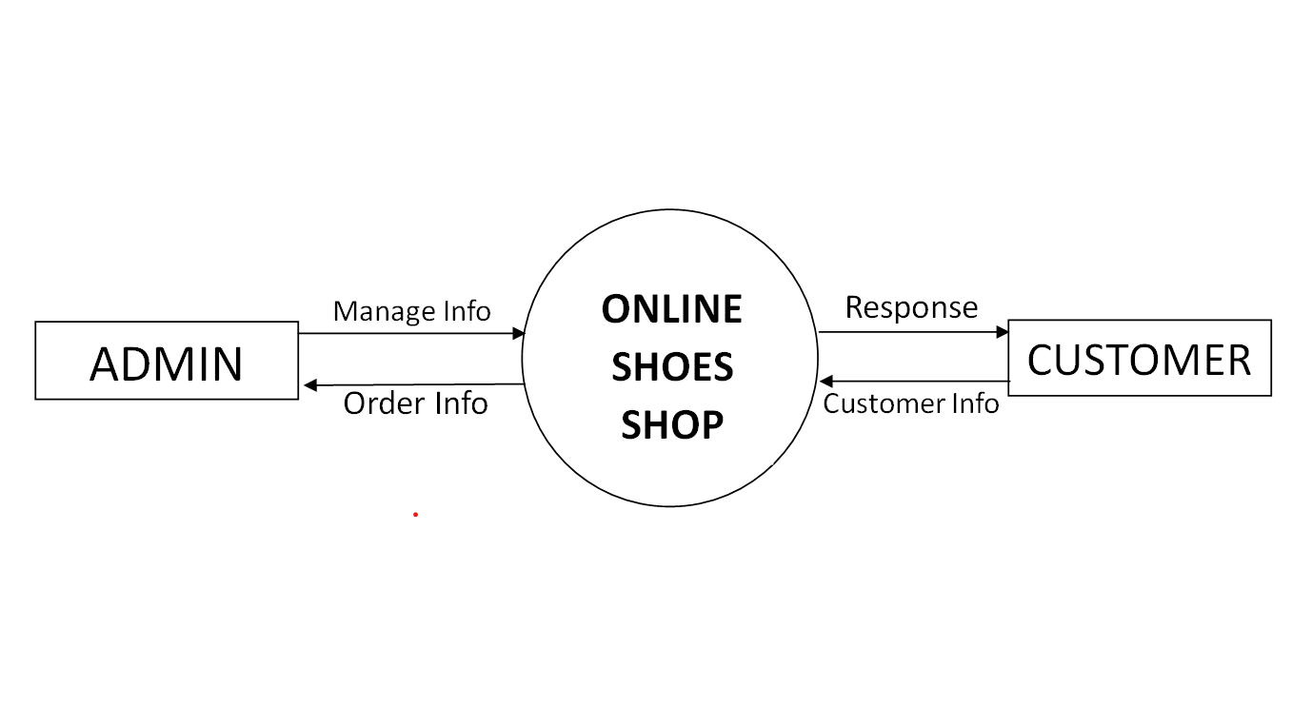

**Zero Level DFD: -**

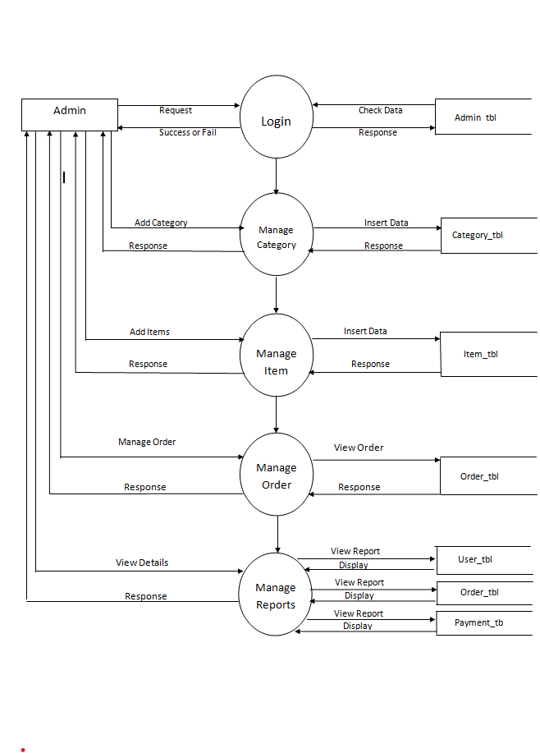

**First Level DFD: -**

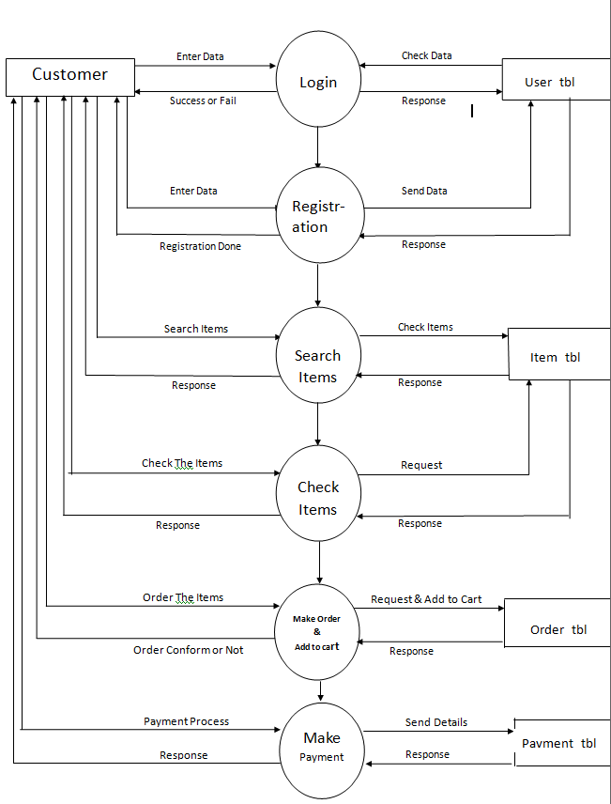

1. **Database Layout**

**1) admin_tbl**

|  |  |  |  |  |  |
| --- | --- | --- | --- | --- | --- |
| Sr. No. | Field Name | Data Type | Size | Constraint | Description |
| 1 | Userid | varchar | 50 |  | User Id |
| 2 | password | varchar | 50 |  | Password |

**2) User login:**

|  |  |  |  |  |  |
| --- | --- | --- | --- | --- | --- |
| Sr. No. | Field Name | Data Type | Size | Constraint | Description |
| 1 | Userid | varchar | 50 |  | User Id |
| 2 | password | varchar | 50 |  | Password |

3) Categories :

|  |  |  |  |  |  |
| --- | --- | --- | --- | --- | --- |
| Sr. No.  **Sr. No.** | Field Name **Field Name** | Data Type **Data**  **Type** | Size | **Cons** Constraint | Description **Desc** |
| 1 | Categoryid | Int |  | Primary Key | Category Id |
| 2 | Cate_name | varchar | 50 |  | Category Name |
| 3 | nu_items | Int |  |  | Number of Items |

4) Registration (Customer registration table):

|  |  |  |  |  |  |
| --- | --- | --- | --- | --- | --- |
| Sr .No.**. No.** | Field Name **Field Name** | Data Type **Data**  **Type** | Size **e** | **s** Constraint **Const** | Description **Descript** |
| 1 | userid | Int |  | Primary Key | User Id |
| 2 | name | nvarchar | 100 |  | Full Name |
| 3 | Email | nvarchar | 50 |  | Email |
| 4 | password | nvarchar | 50 |  | Password |
| 5 | phone | numeric | 18,0 |  | Phone Number |
| 6 | gender | nchar | 10 |  | Gender |
| 7 | pincode | Int |  |  | Pincode |
| 8 | state | nvarchar | 50 |  | State |
| 9 | city | nvarchar | 50 |  | City |
| 10 | address | nvarchar | 200 |  | Address |

5) Item Table:

|  |  |  |  |  |  |
| --- | --- | --- | --- | --- | --- |
| Sr. No. | Field Name | Data Type | Size | Constraint | Description |
| 2 | pid | Int |  | Primary Key | Product Items ID |
| 3 | Pname | Varchar | 50 |  | Item Name |
| 4 | Prices | Decimal | 18,2 |  | Display Price |
| 5 | disc | Varchar | 100 |  | Description |

6) Order_tbl:

|  |  |  |  |  |  |
| --- | --- | --- | --- | --- | --- |
| Sr. No. | Field Name | Data Type | Size | Constraint | Description |
| 1 | Id | int |  | Primary Key | ID |
| 2 | Order Code | Varchar |  |  | Order Code |
| 3 | pid | Int | 50 |  | Item Id |
| 4 | Name | Varchar | 50 |  | Name |
| 5 | UserId | Varchar | 50 |  | User ID |
| 6 | Address | Varchar | 100 |  | Address |
| 7 | State | Varchar | 50 |  | State |
| 8 | City | Varchar | 50 |  | City |
| 10 | Qty | Int |  |  | Quantity |
| 11 | Order Time | Datetime | 50 |  | Order Time |

8) Payment_tbl:

|  |  |  |  |  |  |
| --- | --- | --- | --- | --- | --- |
| Sr. No. | Field Name | Data Type | Size | Constraint | Description |
| 1 | Payment Type | Varchar |  |  | Payment Type |
| 2 | userid | Int |  |  | UserId |
| 3 | Pay_code | Int |  |  | Payment Code |
| 4 | T_amt | int |  |  | Total Amount |

1. **Input Design:**

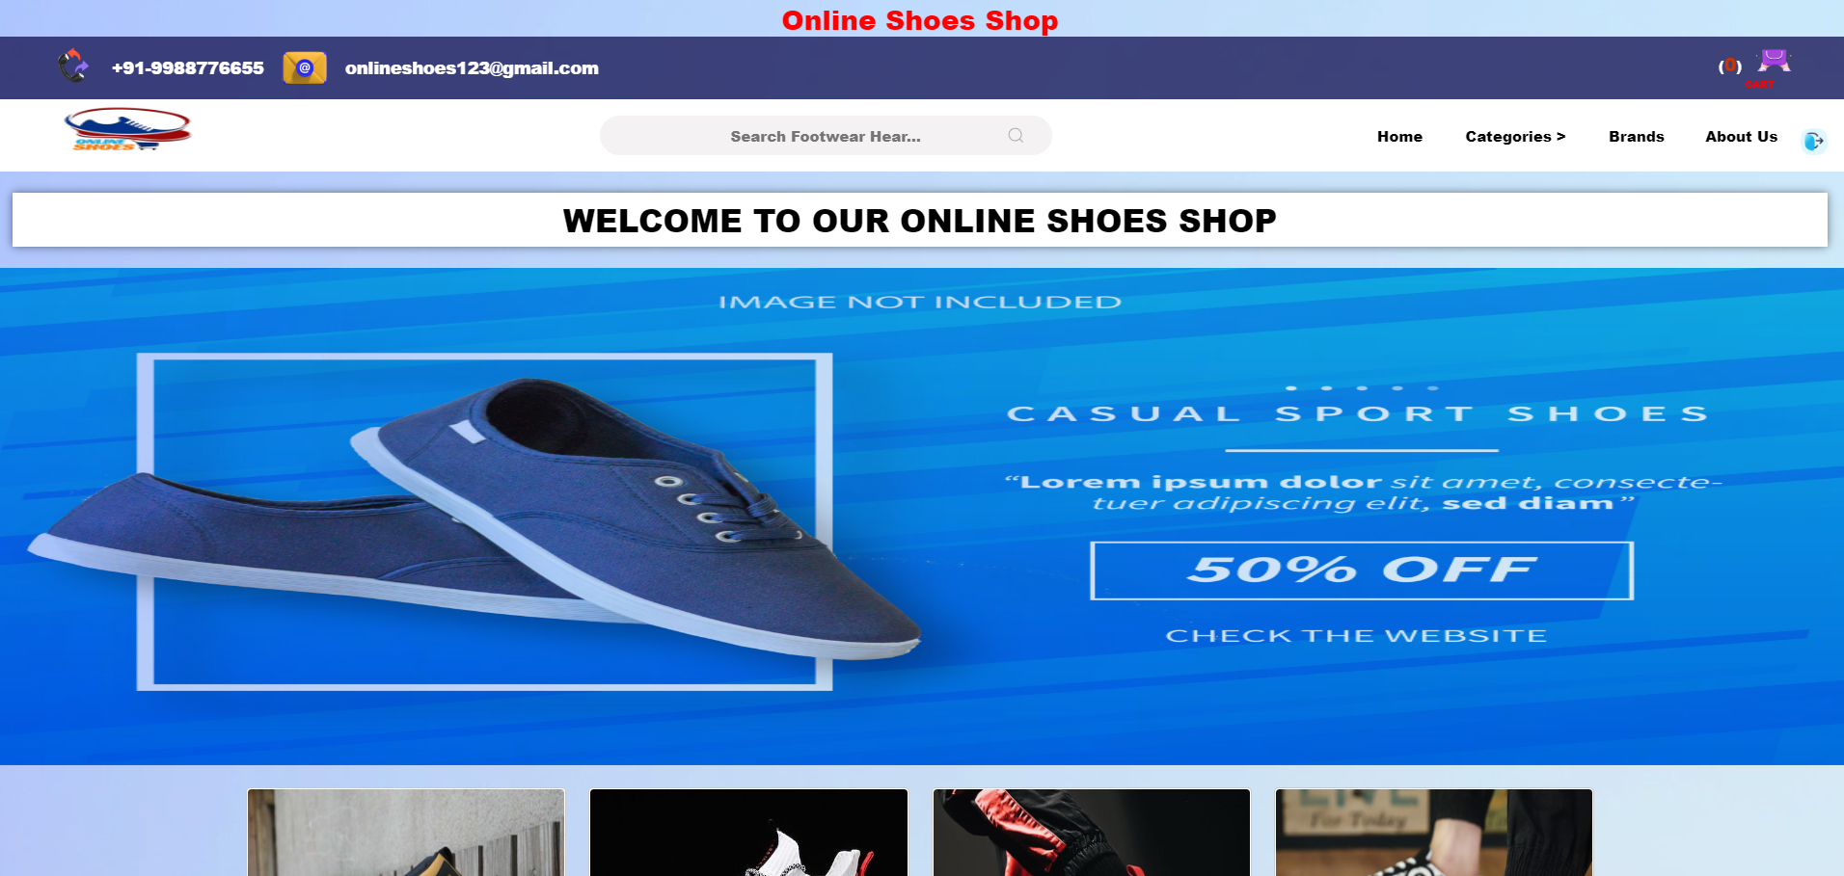**HOME:**

**LOGIN:**

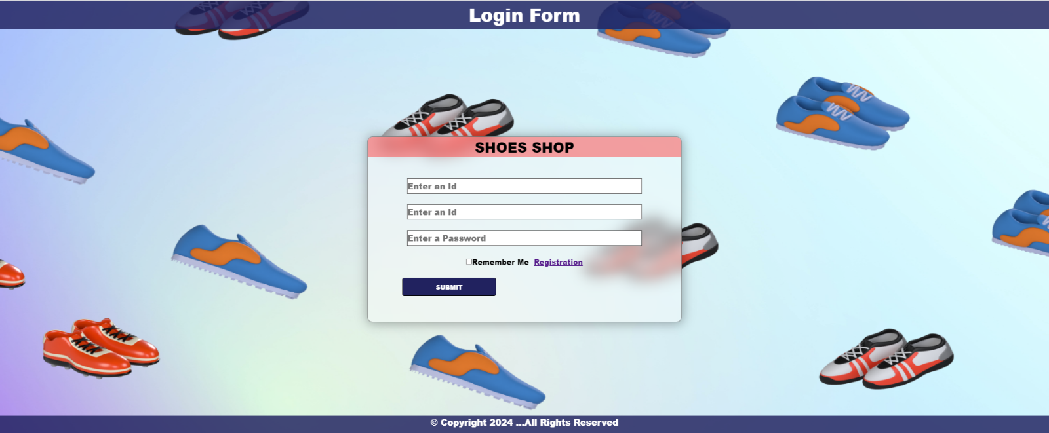

**REGISTRATION:**

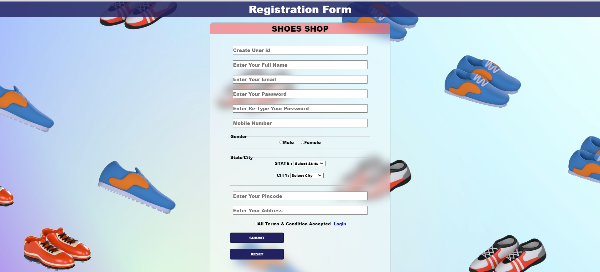

**MAN:**

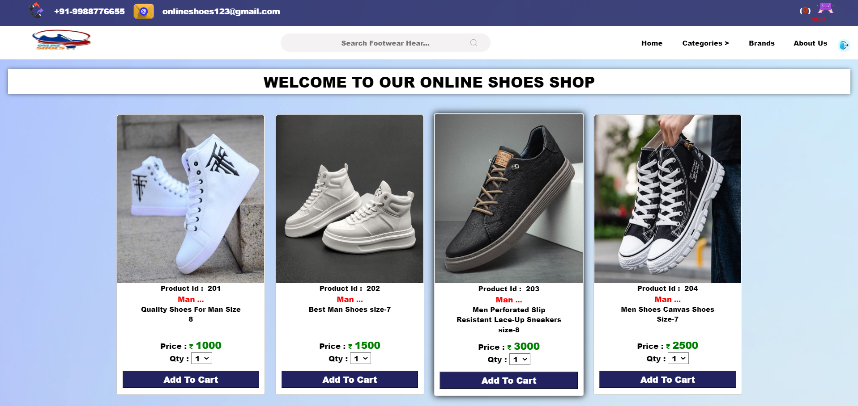

**WOMEN:**

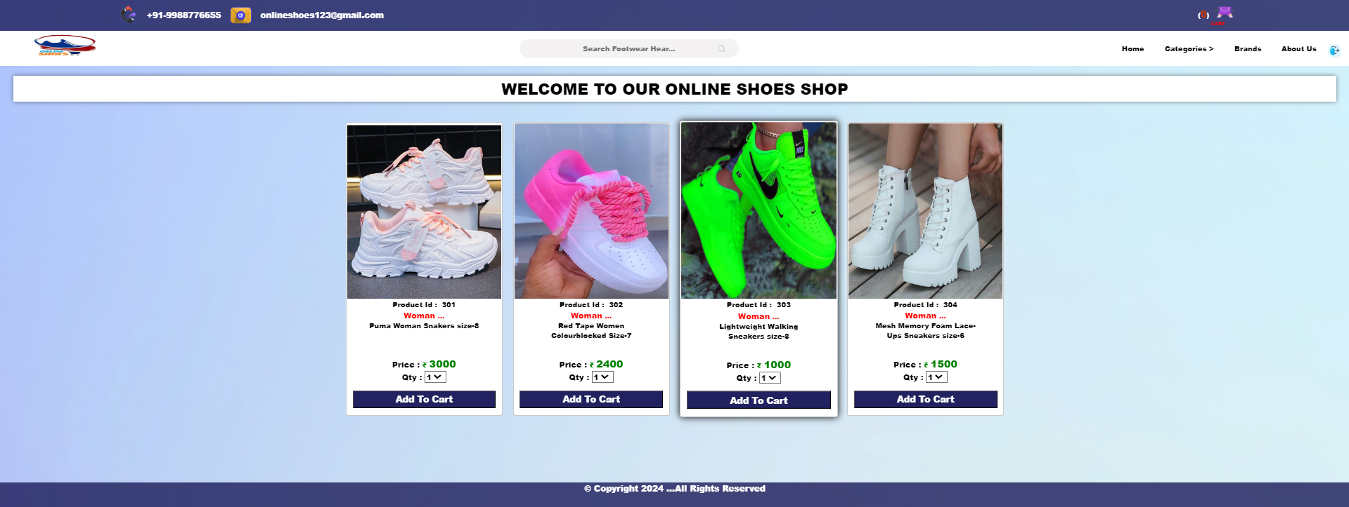

**ADD TO CART:**

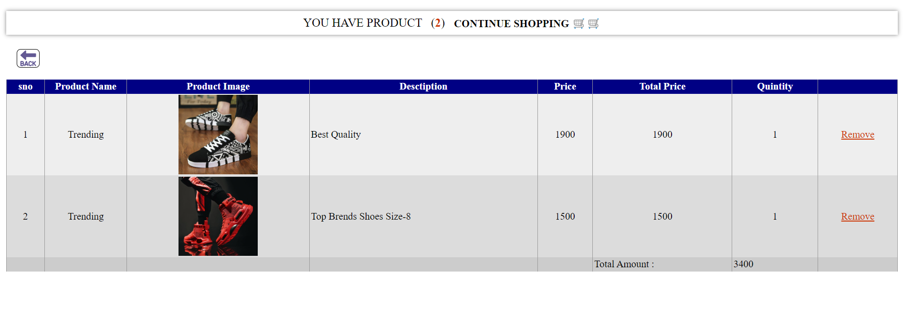

**ADD ADMIN:**

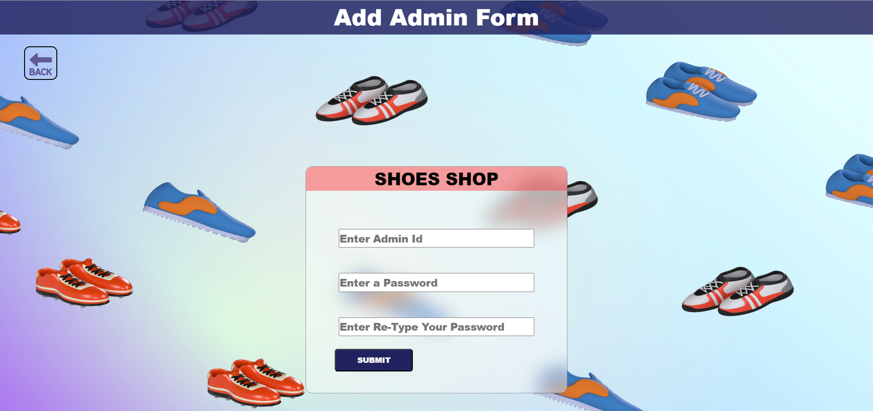

**CUSTOMER:**

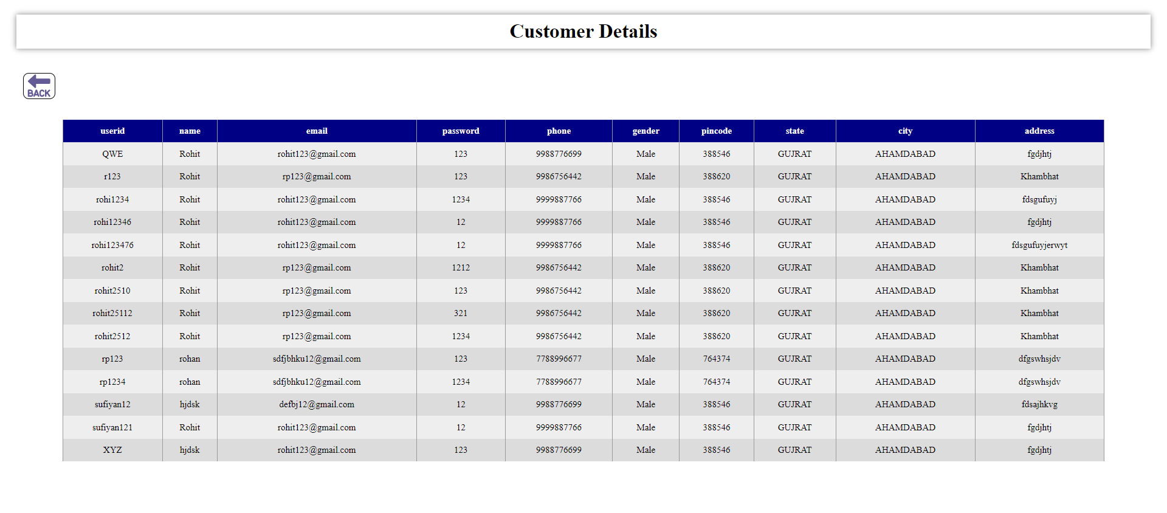

**PRODUCTS:**

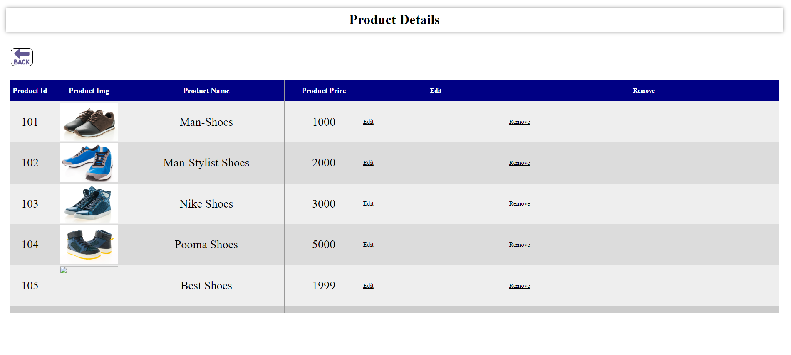

**BRANDS:**

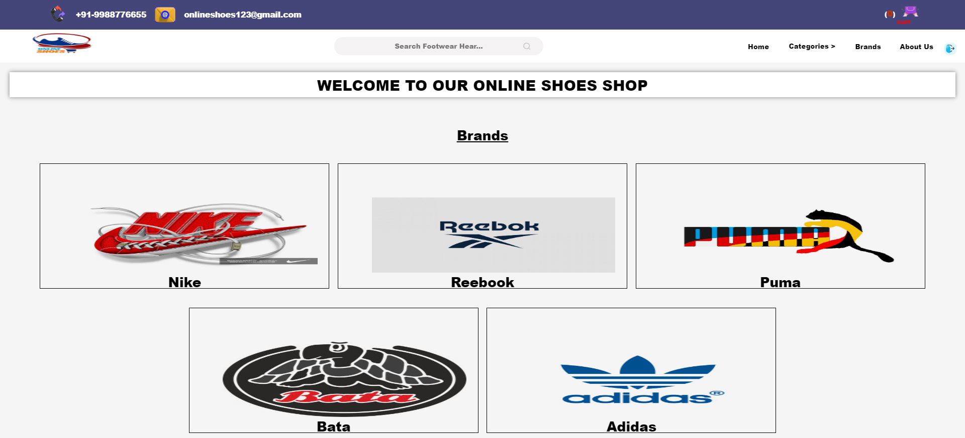

**ADMIN LOGIN:**

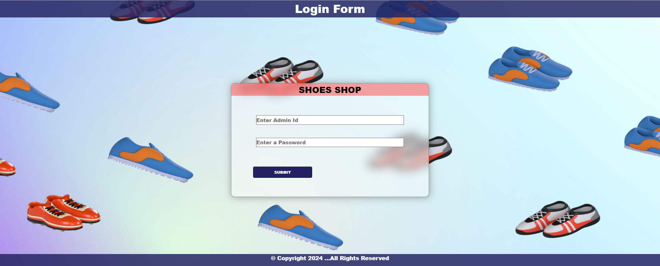

1. **Testing Procedures and Implementation Phases**

Software testing is a critical element of software quality assurance and represents the ultimate reviews of specification, design and coding. The testing phase involves the testing of the system using various test data, preparation of test data plays a vital role in the system testing. After preparing the test data, the system under study is tested using those test data, and errors found are corrected and correction are recorded for future references. Thus, a series of testing is performed before the system is ready for implementation.

**Various types of testing carried out on the system are:**

* Validation testing.
* Output testing.
* User Acceptance Testing.

**Validation Testing:**

Validation and verification are major part of testing.

**Validation:**

The process of evaluating software at the end of its developing process to ensure that it is free from failures and complies with its requirement.

**Verification:**

Verification approaches attempt to identify product faults or errors which give rise to failures.

* **Validation and Verification Techniques:**

First, the validation and verification objectives for our project were decided. During this stage, we have to consider various aspects like constraints, complexities etc. the objectives of validation and verification is to be systematic and technical evaluation of software and their associated product of development.

For this purpose, at the end of the development process, it is very much required to do testing to ensure that the software requirements are compete.

* **Reviews:**

It is always very much required to review a project at the end of a phase to determine whether the requirements are established, design concepts and specifications have been met or not.

For example, if tax rates changes are required, then it should be possible to do so.

* **Inspection or Walkthrough:**

As inspection or walkthrough is a detailed examination of the product on a step-by-step basis. All program codes are subject to review. The purpose is to find errors. The project leader reviews the code to check its functionality.

* **Output Testing:**

After performing validation test the next phase is the output that of the system because no system can be useful if it does not produce the desired output in the desired format. By considering the format of reports, they are generated or displayed, and tested. Here, output format is considered in two ways; one is on the screen and the other is in the printed form.

* **User Acceptance Testing:**

User Acceptance test for a system is the factor the success of the system. The system under consideration is listed for user acceptance by keeping in constant touch with the perspective user of the system at the time of design, development and making changes whenever required. This is done with regards to the following points.

* + Input screen design
  + Output design
  + Menu driven system

1. **Limitation:**

* Sizes may very between brands and style, so Ii’s important to check the size chart before making a purchase.
* Online shoes shop does not allow customers to try on shoes before purchasing them.
* Online shoes shops may have a limited selection of shoes compared to physical store.
* If we have an argent need of shoes for party and occasion, then online shopping will not work.

1. **Proposed Enhancement**

* Offer a wider range of shoes, including different styles.
* Make the website easy to navigate and use.
* Offer responsive and helpful customer service.
* Providing detailed product description and high-quality images.

1. **Conclusion:**

* The online shoes shop industry is a growing and competitive market. Online shoes shops offer a number of advantages over traditional brick-and-mortar stores, including convenience, selection, price, and ease of comparison shopping. To be successful in this market, online shoes shops need to focus on providing a positive customer experience, including a wide selection of high-quality shoes, competitive prices, and a generous return policy.

1. **References:**

* System analysis and design by Elias Award.
* System analysis and design by James A. Senn by TataMacGrows Hill.
* Software Engineering by Pankaj Jalote published by pressman.
* Visual Basic-The complete references.